Nombre____________________________Fecha________________
Español 8 Señorita Ramsaran
“La casa de mis sueños”
In this unit, we will learn about the house and its contents. The purpose of this project is to create your dream house.
Writing
You must describe your dream house in Spanish in 200 words. For example, you must answer:
- How many bedrooms, dining rooms, kitchens, baths, etc. does your house have?
- Describe the structure of the house. How many floors, windows, doors, entrances, etc. does your house have?
- Describe the outer appearance of the house. Does your house have a garden or a pool?
- What kind of furniture do you have in your house? Do you have closet, sofa, bed, lamp, etc.?
- What makes this house special? Why is it your dream house? Do you have an elevator, a basketball court, a mall, a recording studio, a plane, etc.?
Project Visual:
You have three choices for this project.
- A shoebox diorama. All rooms and furniture must be labeled in Spanish.
  - http://www.ehow.com/how_8242382_make-shoebox-house-school-project.html
- An oak tag drawing colored in or pictures neatly pasted. All rooms and furniture must be labeled in Spanish.
- PowerPoint Presentation- 10-12 slides (max)
All labeling should be done in Spanish! For example, instead of “the window” you should write “la ventana.”

Speaking
Each person will present his or her project to the class. They will have 2 minutes to describe their house and why it is the house of their dreams.
(Hint: Write down points on index card to help you study)

Listening
While your classmate is presenting, you will be receive a list of questions to answer base on your classmate’s presentation. The worksheet will be collected and added to your project grade.
Please try your best to be as creative as possible.
***This will be graded as one test grade.****

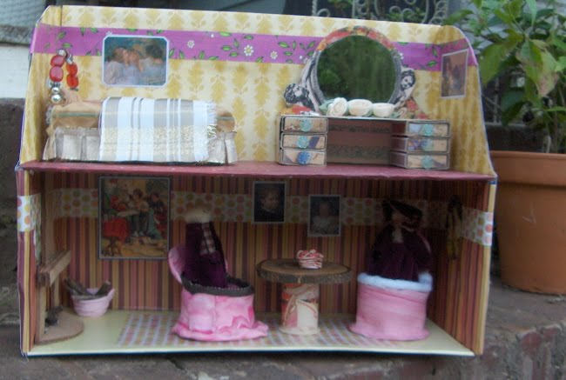

Due Date: February 14, 2014

First Draft Due: February 28, 2014

Second Draft Due: March 7, 2014

